1. Using the different DML commands answer the following questions.
   * SELECT – Number of students enrolled?

There are 40 students enrolled

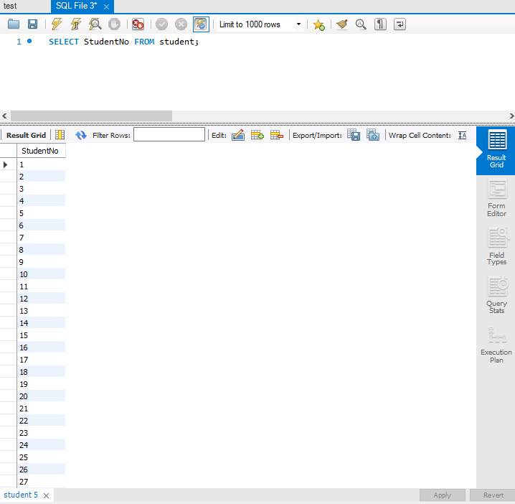

* + SELECT WHERE – Number of students in Computer Science Program?

9 students are in the computer science program

